Non Invasive Glucometer

ABSTRACT:

This project provides a painless, non-invasive method for the detection of glucose level in human body. To control blood sugar levels, the diabetic pierces his fingers (and other parts of the body) daily through pain and the risk of infection from 2 to 8 times. To improve the quality of life of diabetic patients, it is necessary to create non-invasive glucometers, i.e. glucometers, which do not require the receipt of a drop of blood or other biological fluids. In this project, we have proposed a model which can be cost effective and non-obtrusive prototype utilizing NIR (Near Infra-Red) spectroscopy methodology. Optical methods are considered to be one of the promising methods which can be used for non-invasive blood glucose measuring. NIR spectroscopy method is one such optical method.

OBJECTIVES:

To measure blood glucose level of diabetic person without any invasion

To prevent distress caused to patients by repetitive pricking

To eliminate the risk of infection caused in pricked locale

To conquer the troubles of obtrusive techniques

EXECUTION:

Near-infrared rays are passed on one side of the earlobe while the opposite end is the receiver side which receives the attenuated light. Normally, photodiodes are used for light detection at the receiver side. The variations of glucose concentration in the blood attenuate the light transmitted, which results in variation of photodiode voltage. A sensor clip giving near-infrared radiation of 950nm wavelength is used as the transmitter, which penetrates through tissue and attenuates the light signal. And the attenuated signal is perceived by the photodiode, of wavelength 900nm placed in the opposite side of the sensing clip. The sensor part is placed at earlobe for blood glucose level detection. The attenuated rays are converted to respective voltages by the photodiode. The analog signal received from the photodiode is converted into digital signal by the Arduino Nano (Microcontroller) using the analog port. The Bluetooth module is used to transfer the processed data or resultant data (Glucose level) to the Mobile App. Through the Mobile App, the patients can view the glucose level & save it as excel format for future reference. Arduino Nano can be operated at 5V as the input voltage. So, a 5V battery is used for power supply to the device. A switch is used to power ON the device and power cord or Barrel Connector is used for recharging the battery.

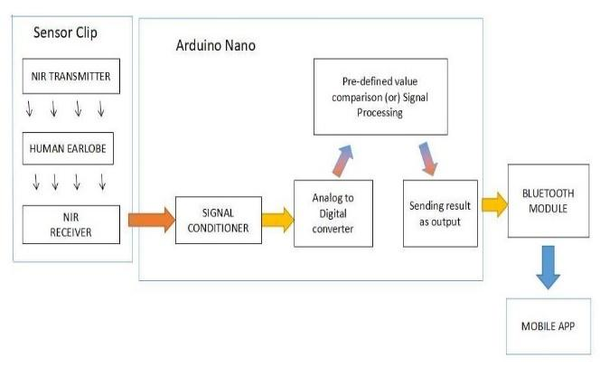

LEARNING OUTCOMES:

Knowledge of NIR Spectroscopy

Working of Arduino Nano

Use of Photodiode

SOCIAL BENEFITS:

The use of this project saves the diabetics from the agonizing pain and torment they have to go through in conventional invasive techniques.

Frequent tracking of blood sugar level reduces the various complications and risk posed by diabetes.

BUDGETARY REQUIREMENTS:

|  |  |  |  |  |
| --- | --- | --- | --- | --- |
| Material/Software required | Specifications | Quantity | Rate (Cost/Quantity) | Total Cost |
| NIR LED (Transmitter) | TSAL5300 | 1 | 400 | 400 |
| Photodiode (Receiver) | BPW34 | 1 | 120 | 120 |
| Arduino Nano | A000005 | 1 | 1710 | 1710 |
| USB Cable | USB 2.0 A to Mini-B | 1 | 260 | 260 |
| LCD Display | 16X2 for Arduino Nano | 1 | 500 | 500 |
| Jumper Wires |  | 20 | 6 | 120 |
| Black Tape | Light Blocking | 1 | 150 | 150 |
| Breadboard |  | 1 | 250 | 250 |
| Fevicol |  | 1 | 50 | 50 |
| Wire Cutter |  | 1 | 150 | 150 |
| Earlobe Clip | Sensor Module | 1 | 100 | 100 |
| Connecting Wires |  | 20 | 10 | 200 |
| Soldering Iron |  | 1 | 170 | 170 |
| Solder wire |  | 1 | 250 | 250 |
| Battery | AA Type | 4 | 20 | 80 |
| Switch |  | 1 | 80 | 80 |
| Battery Holder Socket with cable | For Powering Arduino Nano | 1 | 200 | 200 |

**Final Budget: Rs. 4790**